CHAPTER 1

INTRODUCTION TO IOT SMART IRRIGATION SYSTEM

1.1 Overview
The rapid growth of technology has transformed many traditional practices, and agriculture is one of the fields that has experienced significant advancement. Among the various modern technologies, the Internet of Things (IoT) has played a major role in improving farming efficiency, crop health, and water management. One of the most impactful applications is the IoT Smart Irrigation System, which enables automated and intelligent watering of crops by monitoring environmental conditions in real time.

Traditional irrigation methods depend largely on manual effort, periodic observation, and rough estimation of soil conditions. As a result, farmers often struggle with issues such as over-irrigation, under-irrigation, water wastage, and uneven crop growth. With growing concerns about water scarcity and climate change, there is a strong need for systems that can optimize water usage while maintaining high agricultural productivity. IoT-based smart irrigation provides a reliable solution by combining sensors, microcontrollers, and wireless communication technologies.

An IoT Smart Irrigation System typically consists of soil moisture sensors, temperature and humidity sensors, a microcontroller such as NodeMCU or ESP32, a water pump or solenoid valve, and an internet connection. These components work together to continuously monitor soil conditions and automatically activate irrigation when required. For example, when the moisture sensor detects low water content in the soil, the system turns ON the pump to supply water. Once the required moisture level is restored, the system turns OFF the pump, preventing excess watering.

One of the major advantages of IoT in irrigation is remote monitoring and control. Using cloud platforms such as ThingSpeak, Blynk, or Firebase, users can access real-time data from anywhere using a smartphone or computer. This allows farmers to keep track of moisture levels, pump status, and environmental parameters without being physically present in the field. Alerts and notifications can also be generated whenever critical thresholds are reached, ensuring timely action.
The adoption of IoT-based irrigation systems contributes significantly to water conservation, which is one of the most important global challenges today. By supplying only the required amount of water at the right time, the system minimizes wastage and supports sustainable farming practices. It also improves crop health, as plants receive water based on actual soil conditions rather than a fixed .

From an operational perspective, IoT Smart Irrigation Systems reduce manual labor and save time. Farmers no longer need to frequently check soil conditions or manually operate pumps. The system also helps small and large farms plan better irrigation schedules and reduces dependency on unpredictable rainfall. Over time, this automation leads to increased productivity and cost efficiency.

In addition to basic automation, advanced IoT irrigation systems can integrate weather forecasting, rainfall prediction, and AI-based decision-making. Such enhancements support precision agriculture, where every drop of water and every action is optimized for maximum efficiency.
These innovations make modern farming more intelligent, reliable, and data-driven.

Overall, the IoT Smart Irrigation System is an important technological solution that addresses key challenges in agriculture. It ensures efficient water usage, improves crop yield, reduces human effort, and supports sustainable farming practices. As IoT technology continues to evolve, smart irrigation will become even more advanced, affordable, and widely adopted, playing a crucial role in shaping the future of agriculture.

1.2 IoT Smart Irrigation System

An IoT Smart Irrigation System is an advanced, technology-driven irrigation method that uses the Internet of Things (IoT) to automate and optimize the process of supplying water to crops, gardens, farms, or landscapes. It integrates electronic sensors, microcontrollers, communication modules, and cloud platforms to monitor environmental conditions such as soil moisture, temperature, humidity, and water levels in real time. It integrates electronic sensors, microcontrollers, communication modules, and cloud platforms to monitor environmental conditions such as soil moisture, temperature, humidity, and water levels in real time.
Based on this continuous data, the system intelligently controls the irrigation process by turning the water pump ON or OFF, ensuring that plants receive the exact amount of water required at the right time.
In simple terms, an IoT Smart Irrigation System replaces traditional manual watering with a fully automated, data-driven method. The core idea is that irrigation should occur only when necessary, not based on guesswork or fixed schedules. For example, if the soil moisture sensor detects that the soil is dry, the controller activates the pump to provide water. When the moisture level reaches the optimal range, the pump is turned OFF automatically. This approach helps prevent over-irrigation, under-irrigation, and water wastage—problems commonly faced in traditional irrigation practices.

The term Internet of Things (IoT) refers to a network of physical devices connected to the internet, capable of collecting, sending, and receiving data. When this concept is applied to irrigation, it enables remote monitoring and control of the entire watering system. Farmers or users can access real-time information such as soil moisture levels, pump status, and weather conditions through a mobile application or a web dashboard from anywhere in the world. This remote accessibility allows users to manage their irrigation systems without being physically present in the field, which saves time, effort, and operational costs.

The definition of IoT-based smart irrigation also includes the use of cloud computing, where sensor data is stored and analyzed. Platforms such as ThingSpeak, Blynk, or Firebase enable graphical visualization, data logging, and automation rules. This cloud integration provides valuable insights into irrigation patterns, helping users make informed decisions about water usage, crop planning, and overall farm management. It also supports long-term analysis that can highlight seasonal trends, plant behavior, and environmental changes.

Furthermore, an IoT Smart Irrigation System is designed to be efficient, reliable, and sustainable. By supplying only the required amount of water, the system helps conserve water resources an essential advantage in regions with water scarcity. It enhances crop health and productivity by maintaining consistent soil moisture levels, which are critical for plant growth. The system also reduces the dependency on manual labor, minimizing human error and ensuring irrigation operations continue smoothly even when the user is not present.
In addition to basic automation, modern definitions of IoT smart irrigation incorporate advanced features such as weather forecasting, rainfall detection, and machine-learning-based predictions. These features allow the system to anticipate environmental conditions and adjust irrigation schedules accordingly. For example, if rain is predicted, the system can delay irrigation to prevent. It enhances crop health and productivity by maintaining consistent soil moisture levels, which are critical for plant growth.

1.3 Components
- Soil Moisture Sensor: Measures the water content in the soil A soil moisture sensor is a device that measures the amount of water in the soil, which is essential for efficient irrigation and healthy plant growth
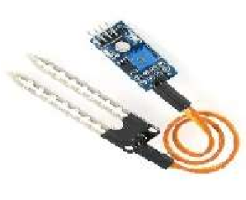
Figure 1.1: Soil Moisture Sensor

- Temperature & Humidity Sensor (DHT11/DHT22): Monitors environmental conditions The primary differences lie in their accuracy, range, and cost, with the DHT22 offering superior performance at a slightly higher price.
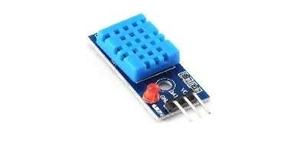
Figure 1.2: Humidity Sensor

- Microcontroller (NodeMCU/ESP32): Processes data and controls actuators. which both feature integrated Wi-Fi connectivity, making them a popular choice for Internet of Things (IoT) projects. The key differences lie in the ESP32's superior processing power, more memory, extra peripherals, and integrated Bluetooth capabilities.
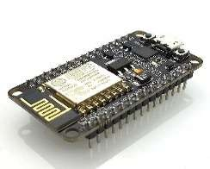
Figure 1.3: NodeMCU ESP8266
- Relay Module: Switches the water pump ON/OFF. A relay module is an electrically operated switch that enables a low-power control circuit (like a microcontroller) to safely manage a separate, much higher-power circuit (like a home appliance or motor)
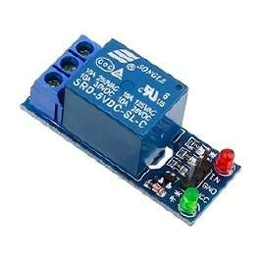
Figure 1.4: Relay Module
- Water Pump/Solenoid Valve: Supplies water to the field. Water pumps and solenoid valves are essential components in fluid control systems for projects like automated watering or aquariums, with pumps providing continuous flow and valves acting as on/off switches for existing pressure
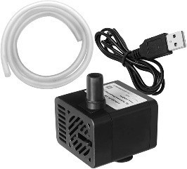
Figure 1.5: Water Pump
- Power Supply: Powers sensors, microcontroller, and pump (can be mains or solar). A power supply unit (PSU) provides the necessary electrical power for electronic components by converting a source voltage (AC or DC) into the specific regulated DC voltages required by the project's components. The type of power supply depends on the project's power needs and portability requirements
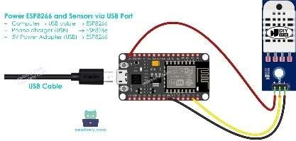
Figure 1.6: USB Power Supply

1.4 Scope of the Project
The scope of the IoT Smart Irrigation System project includes the design, development, and implementation of an automated water management solution for agricultural and garden applications. The project focuses on creating a system that uses IoT-based sensing and communication technologies to monitor soil moisture, environmental conditions, and crop requirements in real time. Based on these data inputs, the system controls the irrigation process automatically, ensuring that water is supplied only when necessary. This results in optimized water usage, improved crop health, and reduced manual intervention.

The project covers the integration of sensors such as soil moisture sensors, temperature and humidity sensors, and optional components like water flow meters or rain sensors. It also includes the use of a microcontroller or NodeMCU/ESP8266 board that collects sensor data and sends it to a cloud platform for monitoring and analysis. The scope further extends to enabling remote access through mobile apps or web dashboards, so that farmers or users can view real-time field conditions and control the system from anywhere.

Additionally, the project aims to support scalability, making it adaptable for small farms, home gardens, or large-scale agricultural fields. It includes provisions for energy-efficient operation, with options like solar-powered systems for use in remote areas. The system is designed to reduce water wastage, lower labor costs, and support sustainable farming practices. While the project focuses mainly on soil-moisture-based irrigation control, it can be expanded in the future to include advanced features such as AI-based crop analysis, predictive irrigation using weather data, and integration with fertilizer automation systems.

The project also lays the foundation for future enhancements, such as adding weather-based predictions, fertilizer mixing automation, water flow monitoring, and advanced data analytics.
These improvements can make the system even more intelligent and resource-efficient.
Overall, the scope defines the boundaries of the project: designing a reliable, cost-effective.

1.5 Motivation

The motivation for developing an IoT Smart Irrigation System comes from the increasing need to use water resources efficiently in agriculture, which is one of the most water-dependent sectors in the world. Traditional irrigation methods such as manual watering, fixed-time sprinklers, or flood irrigation often lead to significant water wastage because they do not consider real-time soil moisture levels or weather conditions. As water scarcity becomes a major global issue— especially in developing countries—there is a growing demand for smarter, automated, and datadriven irrigation solutions. This need forms the primary motivation for this project.

CHAPTER 2

LITERATURE SURVEY

2.1 Introduction
Agriculture is one of the largest consumers of freshwater resources, and inefficient irrigation practices contribute significantly to water wastage and reduced crop productivity. With increasing population growth, climate variability, and water scarcity, there is a growing need for intelligent and sustainable irrigation solutions. In this context, the Internet of Things (IoT) has emerged as a promising technology to modernize traditional irrigation systems by enabling realtime monitoring, automation, and data-driven decision making.
IoT-based smart irrigation systems integrate sensors, microcontrollers, communication networks, and cloud platforms to monitor soil moisture, temperature, humidity, and other environmental parameters. Based on the collected data, these systems automatically control irrigation devices such as pumps and valves, ensuring optimal water usage. Several researchers have proposed and implemented IoT-enabled irrigation models using technologies such as Arduino, NodeMCU, ESP32, LoRa, GSM, and cloud platforms for data visualization and control.
This literature survey reviews existing research work related to IoT-based smart irrigation systems, focusing on system architectures, sensor technologies, communication protocols, control algorithms, and data analytics techniques. The survey also highlights the advantages of smart irrigation over conventional methods, including water conservation, reduced human intervention, and improved crop yield. Furthermore, it identifies the limitations and challenges reported in previous studies, such as sensor accuracy, power consumption, connectivity issues, and scalability.
By analyzing existing literature, this survey aims to provide a comprehensive understanding of current advancements in IoT-based irrigation systems and to identify research gaps that can be addressed in future implementations. The insights gained from this review form the foundation for designing an efficient and reliable smart irrigation system. using technologies such as Arduino, NodeMCU, ESP32, LoRa, GSM, and cloud platforms for data visualization and control.
Water scarcity and inefficient irrigation are major bottlenecks for sustainable agriculture. IoTbased smart irrigation systems employ sensors, connectivity, cloud analytics, and actuators to monitor soil and environmental conditions and automate irrigation decisions improving wateruse efficiency, increasing yields, and reducing labour.
- IoT-Based Smart Irrigation System for Precision Agriculture
This paper presents an IoT-based smart irrigation system aimed at improving water efficiency in agriculture. Soil moisture and environmental sensors are used to collect real-time data, which is processed by a microcontroller to automate irrigation. The system reduces water wastage and minimizes manual intervention. Experimental results show improved crop productivity and efficient water management.
- Design and Implementation of an Automated Irrigation System Using IoT
This study proposes an automated irrigation system using IoT technologies to overcome the limitations of traditional irrigation. The system monitors soil moisture levels and controls irrigation pumps automatically. Cloud connectivity enables real-time monitoring and control. The results demonstrate reduced water consumption and improved irrigation accuracy.
- Low-Cost IoT-Based Smart Irrigation System Using NodeMCU
This research focuses on developing a low-cost smart irrigation system using NodeMCU and soil moisture sensors. The system automates irrigation based on predefined threshold values and provides remote access through a mobile interface. The implementation proves to be affordable and effective for small-scale agricultural applications.
- Cloud-Enabled Smart Irrigation System Using IoT Technology
A cloud-integrated smart irrigation system is presented in this paper. Sensor data is transmitted to a cloud platform for storage, analysis, and visualization. Automated irrigation decisions are made based on real-time sensor inputs. The system enhances monitoring capability and supports efficient water usage.
- Wireless Sensor Network Based Smart Irrigation System
This paper explores the use of wireless sensor networks combined with IoT for smart irrigation. Sensors distributed across agricultural fields collect environmental data and transmit it wirelessly to a central controller. The system ensures efficient water distribution and scalability for large agricultural areas.
- IoT-Based Smart Irrigation System Using Weather Forecasting
This study proposes an intelligent irrigation system that integrates IoT with weather forecasting data. Irrigation schedules are dynamically adjusted based on predicted rainfall and environmental conditions. Results indicate significant water savings and improved crop health. By analyzing existing literature, this survey aims to provide a comprehensive understanding .
- Machine Learning Based Smart Irrigation System Using IoT
such as sensor calibration, connectivity, and maintenance are analyzed. Despite these limitations, the system demonstrates improved water efficiency and reduced labor requirements.
- A Survey on IoT-Enabled Smart Irrigation Systems
This survey reviews existing IoT-based smart irrigation systems, focusing on architectures, sensors, communication protocols, and control techniques. The study highlights the advantages of smart irrigation This paper introduces a smart irrigation system that uses machine learning algorithms to predict soil moisture levels. Historical and real-time sensor data are analyzed to optimize irrigation timing. The system outperforms traditional threshold-based methods, though it requires sufficient training data for accuracy.
- Solar Powered IoT-Based Automated Irrigation System
A solar-powered IoT-based irrigation system is developed to address power supply issues in rural agricultural regions. The system uses energy-efficient sensors and controllers to automate irrigation. The results show reliable performance and suitability for remote farming environments.
10. Performance Analysis of IoT-Based Smart Irrigation Systems
This research evaluates the performance of IoT-based irrigation systems through field testing. Challenges, including water conservation and increased productivity. It also identifies research gaps related to scalability and long-term field validation. , including water conservation and increased productivity. It also identifies research gaps related to scalability and long-term field validation The system uses energy-efficient sensors and controllers to automate irrigation. The results show reliable performance and suitability for remote farming environments.
.

2.2 Problem statement
Traditional irrigation methods rely heavily on manual operation and fixed scheduling, which often leads to over-irrigation or under-irrigation of crops. These practices result in significant water wastage, increased energy consumption, and reduced agricultural productivity. Farmers lack real-time information about soil moisture and environmental conditions, making it difficult to apply the right amount of water at the right time. smart irrigation system can address these challenges by enabling real-time monitoring, automated decision making.
In addition, unpredictable climatic conditions and declining freshwater resources further aggravate the problem. Existing irrigation systems also require continuous human supervision, increasing labor costs and inefficiency, especially in large or remote agricultural fields. Therefore, there is a need for an intelligent, automated, and efficient irrigation system that continuously monitors soil and environmental parameters and controls water supply accordingly.

2.3 Existing solution
- Sensor-Driven Automated Irrigation Systems : Many research and practical implementations use soil moisture sensors to automate watering. These systems typically deploy microcontrollers (e.g., NodeMCU, ESP8266/ESP32) to read soil moisture, temperature, and humidity, then actuate pumps or valves based on preset thresholds. Data is often sent to IoT platforms for remote monitoring and control via mobile apps or dashboards.
Example : A typical IoT smart irrigation prototype uses a NodeMCU with soil moisture, rain, and temperature sensors to measure field conditions and control irrigation in real time, sending updates to users and optimizing water delivery.

- Cloud-Enabled Remote Control and Monitoring Platforms : Several IoT solutions integrate with cloud servers (e.g., Ubidots, Blynk, Adafruit IO) to visualize sensor data, send alerts, and allow remote manual or automated control. These platforms support notifications and analytics to improve irrigation decisions.
Example:IoT systems that upload soil moisture and environment data to a cloud dashboard allow farmers to monitor conditions remotely and adjust irrigation schedules through smartphones or computers.
- Wireless Sensor Networks and Communication Protocols : To cover larger areas or agricultural fields where Wi-Fi may not reach, solutions use LPWAN technologies such as LoRa/LoRaWAN or GSM for long-range, low-power communication. These are more scalable for commercial farms with distributed sensors.

- Intelligent Control with Advanced Algorithms : Some systems adopt advanced control strategies beyond simple thresholds, using fuzzy logic, AI and machine learning to make irrigation decisions based on multiple sensor inputs, weather data, and predictive models. This enhances precision and water savings.
Example : Recent research integrates fuzzy logic with IoT to tailor irrigation decisions with multiple parameter inputs, increasing water efficiency and reducing energy use.

- Commercial and Product Solutions : There are also commercial smart irrigation products and comprehensive systems being deployed in practice:
Farm-grade IoT irrigation solutions : with sensor networks, gateways, cloud analytics, and mobile interfaces for real-time control and optimization.

Note: Even commercially deployed IoT systems still face challenges such as connectivity in rural areas, cost barriers for small farmers, and limited interoperability between platforms.

6. Prototype and Open-Source Projects : Open-source smart irrigation projects (e.g., those built with STM32/ESP32 and MQTT) provide complete IoT architectures that automate watering based on soil moisture and allow user dashboards or custom logic, serving as learning references for student and hobbyist systems

2.4 Existing solution objectives
Existing IoT-based smart irrigation solutions in research and practice aim to address the inefficiencies and limitations of traditional irrigation methods by setting clear technical and agricultural goals. Typical objectives described in related literature and projects include:
- Automated Irrigation Control : To automate the irrigation process by continuously monitoring soil moisture, temperature, and humidity in real time and controlling water delivery (e.g., pumps and valves) without manual intervention. This ensures irrigation only occurs when needed, improving efficiency and crop health.
- Water Conservation and Resource Optimization : To optimize water usage by reducing unnecessary irrigation and leveraging real-time environmental data and decision logic.
This helps conserve water resources and lowers operational costs for farmers.
- Remote Monitoring and Control : To enable remote access and control of irrigation systems via mobile apps or web platforms, allowing farmers to monitor field conditions and adjust irrigation settings from anywhere.
- Low-Cost and Scalable Deployment : To develop cost-effective IoT solutions using affordable microcontrollers (e.g., ESP8266/ESP32) and widely available sensors so that the system can be deployed from small gardens to large agricultural fields.
- Improved Crop Yield and Plant Health : To maintain optimal soil moisture levels tailored to crop requirements, thereby promoting healthier plant growth, reducing plant stress, and increasing overall agricultural productivity.
- smart irrigation system can address these challenges by enabling real-time monitoring, automated decision making, Data Logging, Visualization, and Reporting : To record historical sensor data (soil moisture, temperature, humidity) and generate reports or visual dashboards that support analysis, trend tracking, and informed irrigation planning.
- Adaptive and Intelligent Decision Making : To incorporate intelligent algorithms—such as AI or machine learning—that analyze sensor data and weather information to dynamically schedule irrigation, avoiding over- or under-watering
- smart irrigation system can address these challenges by enabling real-time monitoring, automated decision making,
Data Logging, Visualization, and Reporting : To record historical sensor data (soil moisture, temperature, humidity) and generate reports or visual dashboards that support analysis, trend tracking, and informed irrigation planning

2.5 Existing solution disadvantages
Despite the significant benefits of IoT-based smart irrigation systems, many existing solutions have limitations and drawbacks that hinder their widespread adoption, scalability, and long-term effectiveness. Key disadvantages reported in research and practice include:
- High Initial Cost : IoT irrigation systems require a considerable upfront investment in sensors, controllers, communication modules, cloud services, and installation infrastructure, which can be a major barrier for small-scale or resource-constrained farmers.
- Dependence on Connectivity and Power : Many systems rely on continuous internet connectivity (Wi-Fi, GSM/3G/4G/5G) and uninterrupted power supply. In remote or rural agricultural areas with poor network coverage and unstable electricity, this dependency can cause communication failures and disrupt irrigation control.
- Sensor Reliability and Calibration Issues : Sensors such as soil moisture probes require frequent calibration and maintenance to ensure accurate readings. Environmental factors like dust, humidity, and physical damage can lead to faulty data, resulting in incorrect irrigation decisions.
- Technical Complexity and Maintenance Requirements : Smart irrigation systems involve complex technology that demands regular maintenance, technical expertise, and monitoring. Farmers with limited technical skills may struggle to install, configure, and troubleshoot these systems, increasing dependency on specialized support.
- Lack of Standardization and Interoperability : Heterogeneous sensor types, communication protocols, and cloud platforms often lack interoperability and universal standards, making seamless integration challenging and limiting scalability across different environments and equipment.

- Limited Real-Time Adaptability : Some existing systems are based on simple threshold logic or pre-programmed schedules rather than dynamic, real-time adaptation to rapidly changing environmental conditions (e.g., sudden rainfall or crop stress signals). Cybersecurity and Data Privacy Concerns : Connected IoT systems are vulnerable to cybersecurity risks such as unauthorized access, data tampering, and network attacks. Concerns about data privacy and ownership also affect user trust and adoption.
- Limited Long-Term Validation and Field Testing : Many research prototypes and pilot projects have only been tested in small-scale or controlled environments, with scarce long-term, multi-season field trials to validate real-world performance, reliability, and economic benefits.
- Training and User Adaptation Barriers : Users often need training to interpret sensor data, use mobile dashboards, and configure irrigation logic. Lack of digital literacy among farmers can slow adoption and lead to misuse or neglect of the system.

2.6 Overcome of the problem statement
The limitations of traditional irrigation practices and existing irrigation solutions can be effectively addressed by implementing an IoT-based smart irrigation system. The proposed approach overcomes the identi ied problem statement in the following ways:
- Automated and Intelligent Irrigation : The system continuously monitors soil moisture and environmental parameters using sensors and automatically controls irrigation devices such as pumps and valves. This eliminates manual intervention and prevents overirrigation and under-irrigation.
- Efficient Water Utilization : By supplying water only when soil moisture falls below a predefined threshold, the system ensures optimal water usage. This significantly reduces water wastage and supports sustainable agricultural practices.
- Real-Time Monitoring and Remote Access : IoT connectivity enables real-time data transmission to cloud platforms, allowing farmers to monitor field conditions and control irrigation remotely through mobile or web applications, even from distant locations.
- Adaptability to Environmental Conditions : The system can dynamically respond to changing weather and soil conditions by using sensor data and decision logic, ensuring timely irrigation and improved crop health. Reduced Labor and Operational Cost : Automation minimizes the need for constant human supervision, reducing labor dependency and operational costs, particularly in large or remote agricultural fields.

CHAPTER 3

DESIGN OF THE SYSTEM

3.1 Overview of the system
The IoT-based Smart Irrigation System is designed to automate and optimize the irrigation process by continuously monitoring soil and environmental conditions and controlling water supply accordingly. The system integrates sensors, microcontrollers, communication networks, cloud platforms, and actuators to ensure efficient water usage and minimal human intervention.

The system primarily consists of soil moisture sensors, environmental sensors (temperature and humidity), a microcontroller unit (such as NodeMCU/ESP8266 or ESP32), and water control components including pumps and solenoid valves. Sensor data is collected in real time and processed by the microcontroller to determine the irrigation requirement based on predefined thresholds or control logic.

Using IoT connectivity, the collected data is transmitted to a cloud server where it is stored, analyzed, and displayed on a web or mobile dashboard. This enables farmers to monitor field conditions remotely and receive alerts or notifications regarding irrigation status. The system can also be manually controlled through the dashboard when required.

When the soil moisture level falls below the desired threshold, the system automatically activates the irrigation pump. Once the optimal moisture level is reached, the pump is turned off, preventing over-irrigation and conserving water. The system can be extended by integrating weather data, machine learning algorithms, or solar power to improve accuracy, intelligence, and sustainability.

Overall, the proposed system provides a cost-effective, scalable, and efficient solution for modern agriculture by reducing water wastage, lowering labor costs, and improving crop productivity through smart automation. Once the optimal moisture level is reached, the pump is turned off, preventing over-irrigation and conserving water The system can be extended by integrating weather data, machine learning algorithms, or solar power to improve accuracy, intelligence, and sustainability

3.2 System Architecture
The system architecture of the IoT-based Smart Irrigation System is designed in a layered manner to ensure efficient data collection, processing, communication, and irrigation control. The architecture consists of four main layers: Sensing Layer, Control Layer, Communication Layer, and Application Layer.
- Sensing Layer
The sensing layer includes sensors such as soil moisture sensors, temperature sensors, and humidity sensors deployed in the agricultural field. These sensors continuously monitor soil and environmental conditions and generate real-time data required for irrigation decision making.
- Control Layer
The control layer consists of a microcontroller unit (NodeMCU/ESP8266 or ESP32). It collects sensor data from the sensing layer and processes it using predefined threshold values or control algorithms. Based on the processed data, the controller decides whether to turn the irrigation pump ON or OFF.
- Communication Layer
The communication layer enables data transmission between the field unit and the cloud platform. Technologies such as Wi-Fi, GSM, or LoRa are used depending on network availability. This layer ensures reliable and real-time transfer of sensor data and control commands.
- Application Layer
The application layer includes the cloud server, database, and user interface. Sensor data is stored and visualized on web or mobile dashboards. Users can monitor soil conditions, receive alerts, and manually control the irrigation system if required.
- Working of the Architecture
When soil moisture falls below a predefined threshold, sensor data is sent to the controller, which activates the irrigation pump through a relay module. Once the desired moisture level is achieved, the pump is automatically turned OFF. All sensor readings and pump status are updated on the cloud platform in real time.
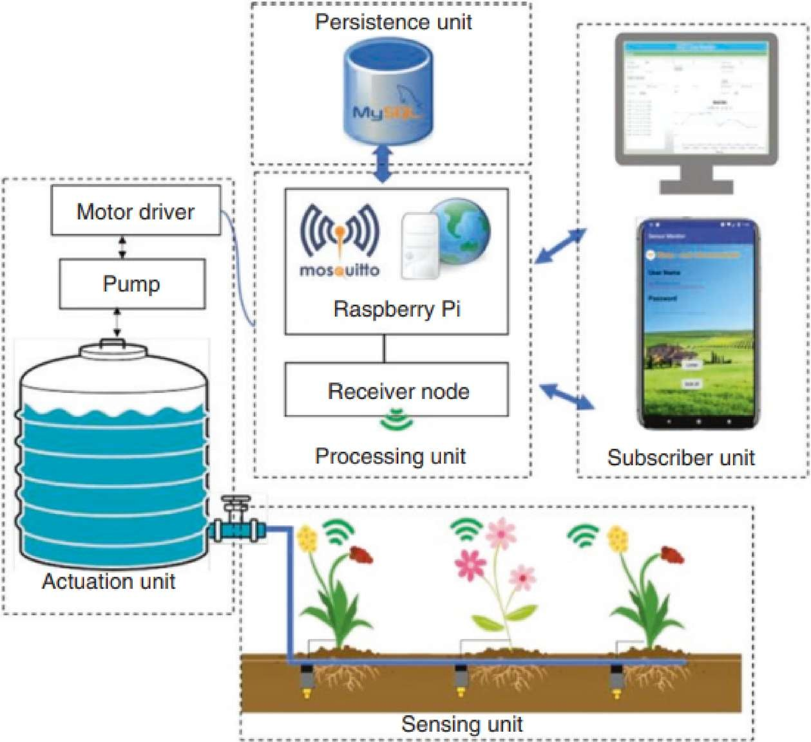
Figure 3.1 : System architecture

The system architecture of the IoT-based Smart Irrigation System is designed to provide an efficient, automated, and scalable solution for modern agricultural irrigation. The architecture integrates sensing devices, a processing unit, communication modules, cloud services, and control mechanisms to ensure optimal water usage with minimal human intervention. The overall design follows a layered approach to simplify data flow, improve reliability, and support future expansion. At the field level, various sensors such as soil moisture sensors and environmental sensors. The ESP32 uses its built-in Wi-Fi to transmit sensor data to cloud platforms (like Blynk or ThingSpeak). Users can monitor soil health in real-time or manually override the system via a smartphone app.
Power Supply A Power Supply unit regulates incoming power (from a wall outlet or battery) to provide stable 3.3V or 5V for the electronics and often a separate higher voltage (like 12V) for the pump . The ESP32 uses its built-in Wi-Fi to transmit sensor data to cloud platforms (like Blynk or ThingSpeak). Users can monitor soil health in real-time or manually override the system via a smartphone app.

3.3 Proposed System
- fields.
- Optional Enhancements:
  - Solar-powered operation.
  - Integration with weather forecasts.
- Intelligent irrigation using machine learning for adaptive water management. Purpose: Automates irrigation to optimize water usage and improve crop yield.
- Sensors Used:
  - Soil moisture sensors measure water content.
  - Temperature sensors monitor ambient heat.
  - Humidity sensors assess surrounding environmental conditions.
- Real-Time Monitoring: Continuously collects accurate data to determine actual water requirements.
- Microcontroller Unit:
  - Uses NodeMCU or ESP32.
  - Processes sensor data and compares with predefined thresholds.
- Automated Irrigation Control:
  - Activates pump or solenoid valve when soil moisture is low.
  - Deactivates irrigation when optimal moisture is reached, preventing overwatering.
- Water and Labor Efficiency: Reduces manual labor and conserves water by precise irrigation.
- IoT Connectivity:
  - Sends data to a cloud platform for remote monitoring and control.
  - Farmers can visualize soil conditions, receive alerts, and manually override the system.
- Data Storage and Analysis: Historical data helps identify irrigation patterns, optimize schedules, and support predictive models.
  - Cost-Effective and Scalable: Suitable for small farms and large agricultural
- Sustainability: Ensures optimal crop growth, conserves water, and reduces operational costs.

3.4 Data flow diagram
The Data Flow Diagram (DFD) of the proposed IoT-based Smart Irrigation System represents how data moves between sensors, controllers, cloud servers, and user interfaces. The system primarily involves four entities: the field sensors, the microcontroller unit, the cloud platform, and the user interface..
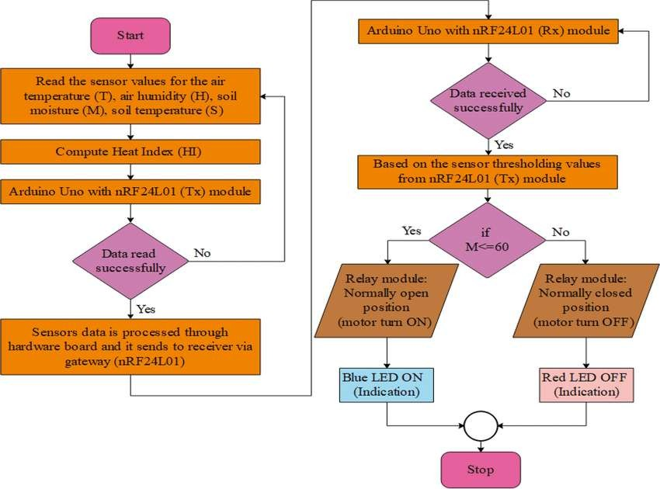

Figure 3.2: Data flow diagram
Start
The system initializes and prepares to read sensor data.
Sensor Data Collection
- The system reads values from sensors for:
  - Air Temperature (T)
  - Air Humidity (H)
  - Soil Moisture (M)
  - Soil Temperature (S)
  - Compute Heat Index (HI)
- The Heat Index, which accounts for temperature and humidity, is calculated.
  - Transmit Data Using Arduino Uno (Tx)
- The Arduino Uno equipped with the nRF24L01 transmitter module sends the sensor data to a remote receiver.
  - Check if Data is Read Successfully (Tx Side)
  - No: Retry reading the sensor data.
  - Yes: Proceed to the next step.
  - Data Reception (Rx Side)
- Arduino Uno with nRF24L01 receiver module receives the transmitted sensor data.
Check if Data is Received Successfully
  - No: Wait/retry until data is successfully received.
  - Yes: Compare sensor readings against threshold values.
- Soil Moisture Check
- If soil moisture (M) ≤ 60 (threshold): .
Stop
- The process either ends or loops back to continuously monitor soil and environmental conditions.

3.5 Workflow
The system senses the water level using a sensor and displays the value. If the water level is low, the pump is turned ON to start pumping water. The system continuously monitors the level during pumping. Once the water level reaches medium or high, the pump is automatically turned OFF. This process repeats continuously to maintain proper water levels and avoid wastage. The system senses the water level using a sensor and displays the value. If the water level is low, the pump is turned ON to start pumping water. The system continuously monitors the level during pumping. Once the water level reaches medium or high, the pump is automatically turned OFF.
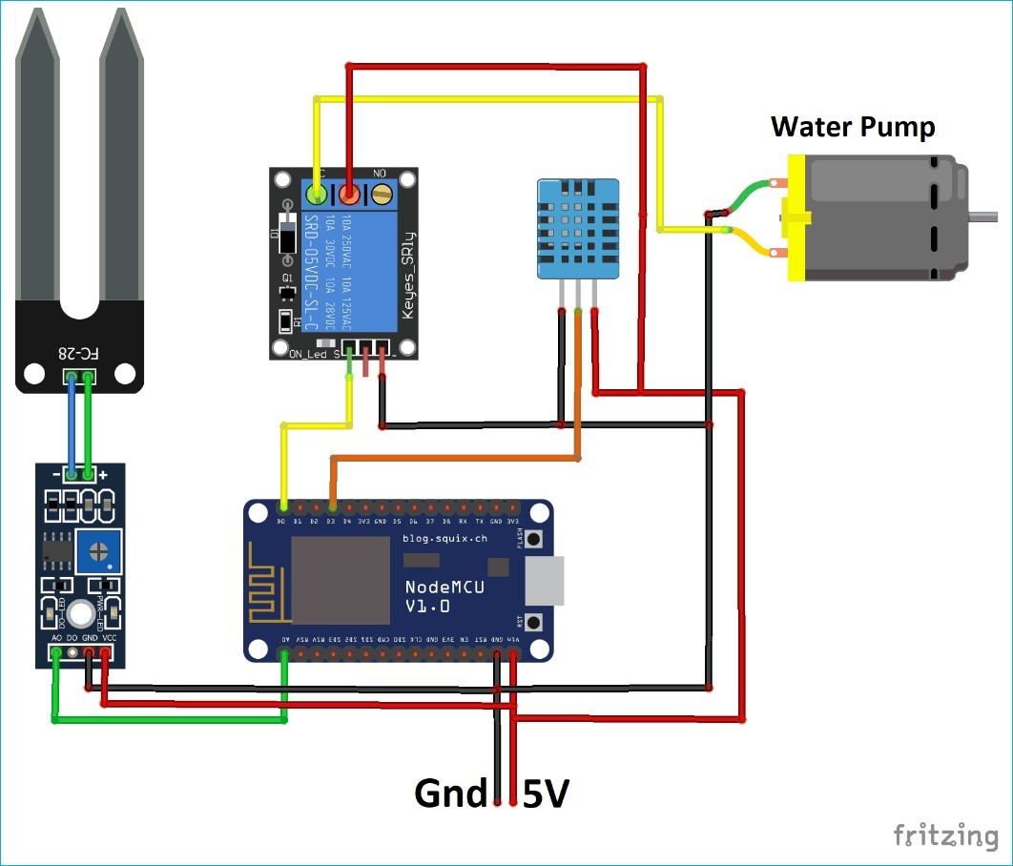
This process repeats continuously to maintain proper water levels and avoid wastage.

Figure 3.3: Workflow
The workflow of the proposed smart irrigation system involves the following sequential steps:
1. Sensor Data Acquisition
- Sensors for soil moisture, soil temperature, air temperature, and humidity continuously monitor field conditions.
- Data is read periodically to ensure real-time monitoring.
2. Data Processing
- The collected sensor data is sent to a microcontroller (e.g., Arduino Uno, NodeMCU, or ESP32).
- The microcontroller processes the data and calculates important indices, such as the Heat Index (HI), to understand crop water requirements.
- Data Transmission
  - The processed data is transmitted wirelessly using nRF24L01 modules from the transmitter unit (Tx) to the receiver unit (Rx).
  - Data transmission ensures communication between field sensors and the control system.
- Decision Making
- The receiver microcontroller evaluates the received sensor data against predefined threshold values.
- For example, if the soil moisture level is below the set threshold, irrigation is required.
- Actuation
- Based on the decision:
- The relay module turns ON the water pump if irrigation is needed (soil moisture low).
- The relay turns OFF the pump when soil moisture reaches optimal levels.
- User Indication and Control
  - LED indicators provide visual status: Blue LED for pump ON, Red LED for pump OFF.
  - Optional IoT interface allows remote monitoring and manual override via mobile or web application.
- Continuous Loop
  - The workflow repeats at regular intervals to maintain optimal soil moisture, ensuring efficient water usage and healthy crop growth.

3.6 Application
The IoT-based smart irrigation system has diverse applications in modern agriculture and related areas:
- Precision Agriculture
  - Optimizes water usage by irrigating crops only when needed based on real-time soil moisture and environmental data.
  - Improves crop yield and quality by maintaining optimal growing conditions.
- Water Conservation
  - Reduces water wastage by preventing over-irrigation.
  - Supports sustainable agriculture practices, especially in water-scarce regions.
- Remote Monitoring and Control
  - Farmers can monitor soil and environmental conditions remotely via web or mobile applications.
  - Provides alerts and allows manual intervention if necessary.
- Scalable Farm Management
  - Suitable for small-scale farms as well as large agricultural fields.
  - Can be integrated with other IoT devices and sensors for comprehensive farm automation.
- Integration with Renewable Energy
  - Can be combined with solar-powered irrigation pumps for energy efficiency.
- Data-Driven Decision Making
  - Historical sensor data can be analyzed to plan irrigation schedules, predict water requirements, and implement machine learning models for intelligent irrigation.
- Urban and Indoor Farming
  - Can be used in greenhouses, vertical farms, and urban agriculture setups for precise water and nutrient management.
- Environmental Monitoring
  - Helps in monitoring microclimate conditions like temperature, humidity, and soil health, which is crucial for crop growth and sustainability. conditions like temperature, humidity, and soil health, which is crucial for crop growth and sustainability.

3.7 Advantages
- Water Efficiency
  - The system monitors soil moisture in real time and irrigates only when necessary, preventing unnecessary water usage.
  - This ensures that crops receive the right amount of water, conserving this precious resource, which is especially important in regions facing water scarcity.
  - Over-irrigation, which can cause soil erosion and nutrient leaching, is minimized.
- Labor Savings
  - Traditional irrigation requires farmers to manually operate pumps or open/close valves.
  - The automated system eliminates the need for constant human supervision, allowing farmers to focus on other tasks.
  - This is particularly valuable for large farms where manual irrigation is time-consuming and labor-intensive.
- Improved Crop Yield
- Consistent and precise irrigation maintains optimal soil moisture levels, which is crucial forcrop growth.
- By preventing water stress (too little or too much water), the system enhances plant health, reduces disease risk, and increases productivity.
- Farmers can achieve higher quality crops, which can also improve market value.
  - Remote Monitoring and Control With IoT connectivity, sensor data is transmitted to the cloud, allowing farmers to access it via mobile apps or web interfaces.
  - With IoT connectivity, sensor data is transmitted to the cloud, allowing farmers to access it via mobile apps or web interfaces.
  - They can monitor soil moisture, temperature, and humidity remotely in real time.
  - The system allows manual override of irrigation if needed, providing full control even when the farmer is not physically present.

- Cost-Effective
  - Reduces operational costs by saving water, energy, and labor.
  - Automated irrigation reduces the risk of crop damage due to over- or under-watering, potentially saving costs associated with crop loss.
  - The initial investment is offset by long-term savings in water bills, electricity, and labor wages.
- Scalability
    - The system can be implemented on small farms, gardens, or large agricultural fields.
    - Multiple sensors and pumps can be added as needed without significant changes to the core system.
    - Its modular design allows farmers to expand their irrigation system gradually as their farm size or requirements grow.
- Data-Driven Decisions
    - Historical data collected from sensors helps analyze soil and crop conditions over time.
    - Farmers can identify irrigation patterns, predict water needs for different crops, and plan schedules effectively.
    - Integration with machine learning algorithms in future versions can provide predictive irrigation, further optimizing water and nutrient use.
- Energy Efficiency
    - The system can integrate with solar panels or other renewable energy sources to power pumps, reducing dependence on electricity.
    - Automation ensures pumps operate only when necessary, avoiding energy wastage..
- Environmentally Friendly
    - Prevents over-irrigation, which can lead to soil degradation, nutrient runoff, and waterlogging.
    - Conserves water resources, protects soil structure, and reduces the carbon footprint of farming operations.

CHAPTER 4

REQUIREMENT SPECIFICATION

4.1 Introduction
The IoT Smart Irrigation System is an automated watering solution designed to efficiently manage the irrigation process using real-time sensor data and internet-based monitoring. The system integrates soil moisture sensors, environmental sensors, a microcontroller (such as NodeMCU/ESP8266), and a water pump controlled through a relay. By continuously monitoring the soil’s moisture level, the system determines the exact amount of water required by plants, ensuring optimal irrigation without human intervention. This reduces water wastage, saves time, and supports healthy crop growth.

The system functions by collecting data from various sensors, processing it through the microcontroller, and then making intelligent decisions based on predefined thresholds. When the soil moisture level falls below a set limit, the microcontroller automatically triggers the relay to start the water pump. Once the desired moisture level is achieved, the pump is switched off. This closed-loop automation ensures accurate and timely irrigation. Additionally, the system uploads sensor readings—such as soil moisture, temperature, and humidity—to an IoT cloud platform where the user can view updates in real time.

Remote monitoring is a key aspect of the system. Through cloud dashboards or mobile applications, users can track live field conditions and manually control the pump if necessary. This feature allows farmers or gardeners to manage irrigation from anywhere, making the system convenient and user-friendly. Moreover, the system’s modular design allows customization for different field sizes, ranging from small home gardens to large agricultural farms. It also supports the integration of renewable energy sources like solar panels for uninterrupted operation in remote areas.
Overall, the IoT Smart Irrigation System provides an effective, sustainable, and technologically advanced solution for modern agriculture. It ensures precise water management, reduces manual effort, and contributes to long-term resource conservation. The system serves as a foundation for

4.2 Functional Requirements (FR)

- Soil Moisture Monitoring
  - The system shall continuously measure soil moisture levels using sensors deployed in the field.
- Temperature and Humidity Monitoring
  - The system shall record ambient temperature and humidity to assess environmental conditions affecting irrigation needs.
- Water Pump Control
  - The system shall automatically turn the water pump ON when soil moisture falls below a predefined threshold.
  - The system shall turn the pump OFF when the soil moisture reaches the desired level.
- Data Transmission
  - The system shall transmit real-time sensor data to a cloud server or a local database for analysis.
- User Interface
  - The system shall provide a web/mobile interface to monitor soil moisture, temperature, humidity, and irrigation status.
- Manual Override
  - The system shall allow manual control of the water pump via the user interface, overriding automatic operation.
- Scheduling
  - The system shall allow users to set irrigation schedules based on time, frequency, or crop requirements.
- Alert and Notification
  - The system shall send alerts or notifications to the user when soil moisture is critically low or in case of system malfunction.
- Data Logging and History
  - The system shall log sensor readings and irrigation events for historical analysis and reporting.
- Energy Efficiency
  - The system shall optimize pump usage to conserve electricity and water resources.

4.3 Non-Functional requirements

- Performance
  - The system shall respond to sensor data within 5 seconds for real-time monitoring and irrigation control.
- Reliability
  - The system shall maintain continuous operation with minimal downtime (uptime ≥ 99%).
  - Sensors and pumps shall operate reliably under outdoor conditions.
- Scalability
  - The system shall support expansion to additional sensors or multiple fields without major redesign.
- Security
  - The system shall ensure secure transmission of data using encryption protocols to prevent unauthorized access.
  - User authentication shall be required to access the system interface.
- Usability
  - The user interface shall be intuitive and easy to operate for users with minimal technical knowledge.
- Maintainability
  - The system shall allow easy replacement or upgrade of sensors, pumps, and software components.
- Availability
  - The system shall be accessible remotely via web or mobile apps 24/7.
- Portability
  - The system shall be compatible with multiple devices, including smartphones, tablets, and PCs.
- Energy Efficiency
  - The system shall optimize water pump usage to minimize power consumption.
- Environmental Compliance
  - The system shall operate safely under varying environmental conditions (temperature, humidity, rain).

4.4 Hardware requirements
- Soil Moisture Sensor: Measures the water content in the soil.

- Temperature & Humidity Sensor (DHT11/DHT22): Monitors environmental conditions.

- Microcontroller (NodeMCU/ESP32): Processes data and controls actuators.

- Relay Module: Switches the water pump ON/OFF.

- Water Pump/Solenoid Valve: Supplies water to the field.

- Power Supply: Powers sensors, microcontroller, and pump (can be mains or solar).

4.5 SOFTWARE COMPONENTS
- Arduino IDE : Used to write, compile, and upload the program into the NodeMCU ESP8266.
- ThingSpeak IoT Cloud : Stores sensor data online and displays real-time graphs for remote monitoring.

- Embedded C / C++ : Programming language used to control sensors, relay, and cloud communication.
- IoT Cloud API / HTTP Communication : Allows NodeMCU to send data to ThingSpeak using internet-based API requests.

CHAPTER 5

RESULT AND ANALYSIS

5.1 Analysis of results
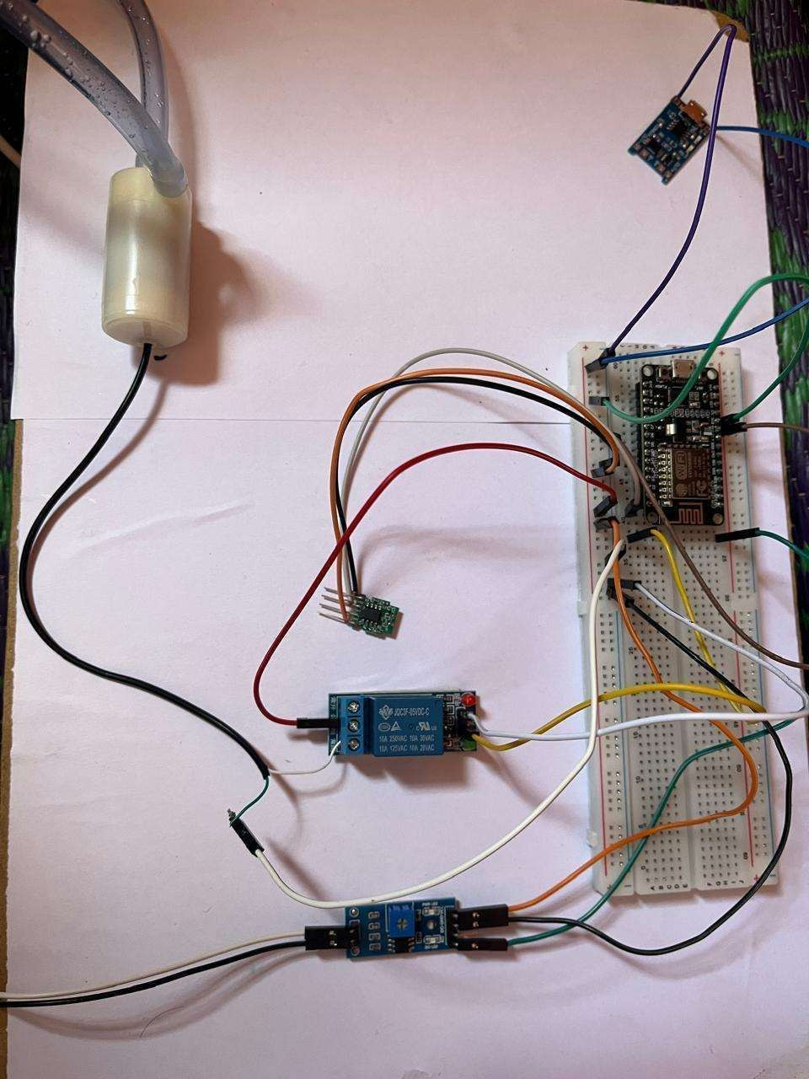

Snapshot 5.1: Basic Module
An IoT-based Smart Irrigation System consists of several basic modules that work together to automate and optimize water usage in agriculture. The Sensor Module collects real-time data from the field, such as soil moisture, temperature, and humidity, using devices like soil moisture sensors, DHT sensors, and weather sensors. The Control Module processes this data and makes decisions based on predefined thresholds, for example, turning the water pump on or off. A smart irrigation system operates as a cohesive unit of modular hardware designed to automate water management through real-time environmental data. At its core, the Data Acquisition Module employs soil moisture sensors to detect volumetric water content and DHT sensors to monitor ambient temperature and humidity. This data is transmitted to the Processing & Control Module,
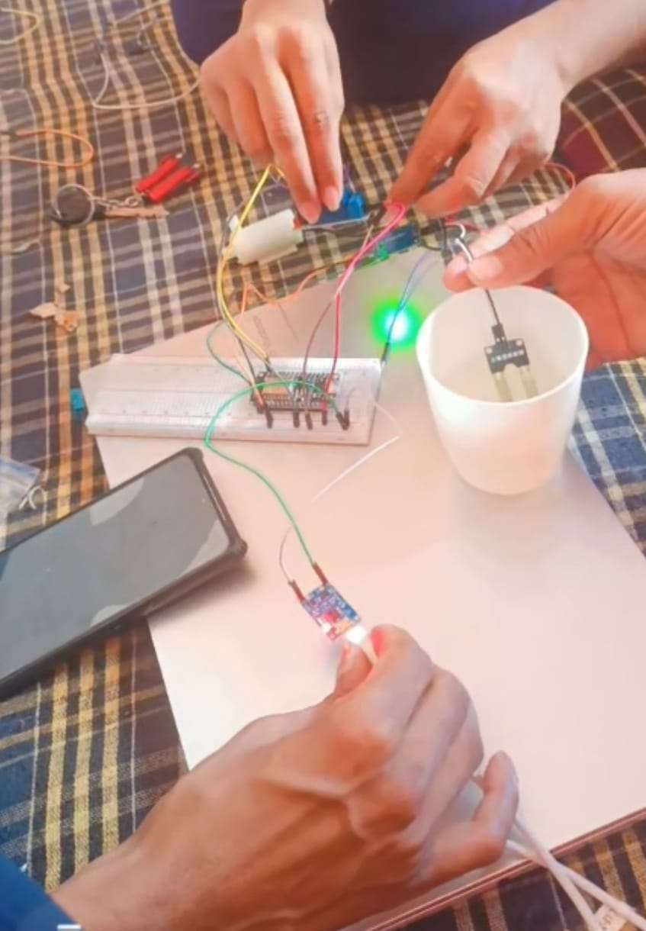

Snapshot 5.2: working Module
The working module describes the step-by-step operation of the IoT-based environmental monitoring system. The system continuously monitors environmental parameters such as temperature, humidity, and pressure and uploads the data to the ThingSpeak cloud platform for real-time visualization and analysis.
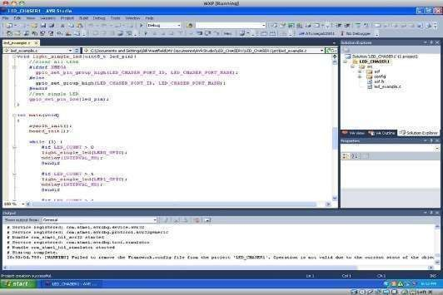

Snapshot 5.3: Arduino IDE
The Arduino IDE is an open-source software application used to write, compile, and upload programs (called sketches) to Arduino boards and other compatible microcontrollers such as NodeMCU (ESP8266), ESP32, etc. It provides a simple and user-friendly interface, making it ideal
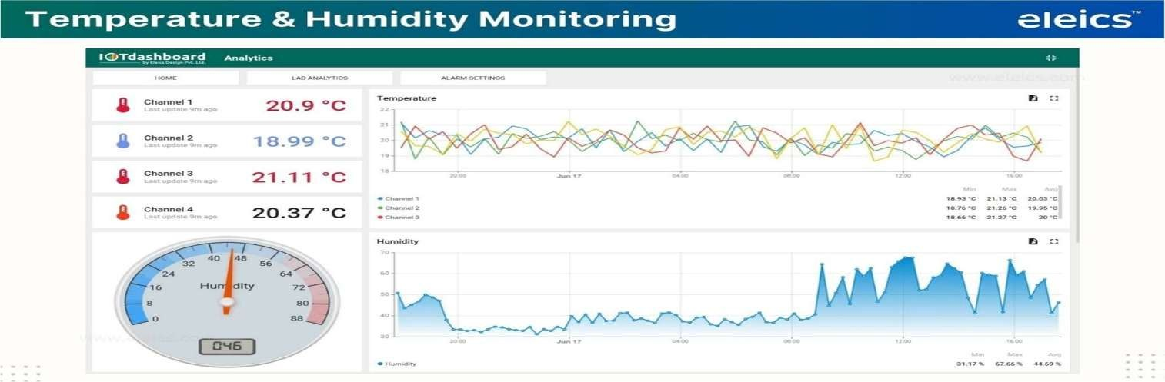
Snapshot 5.4: Temperature & Humidity Analysis (DHT11)

The temperature and humidity readings help analyze environmental conditions. The system uses this data to understand plant-friendly conditions and improve irrigation efficiency. The collected data is uploaded to the ThingSpeak cloud, where it is displayed in the form of graphs for easy monitoring. By observing temperature and humidity trends, farmers can understand environmental.
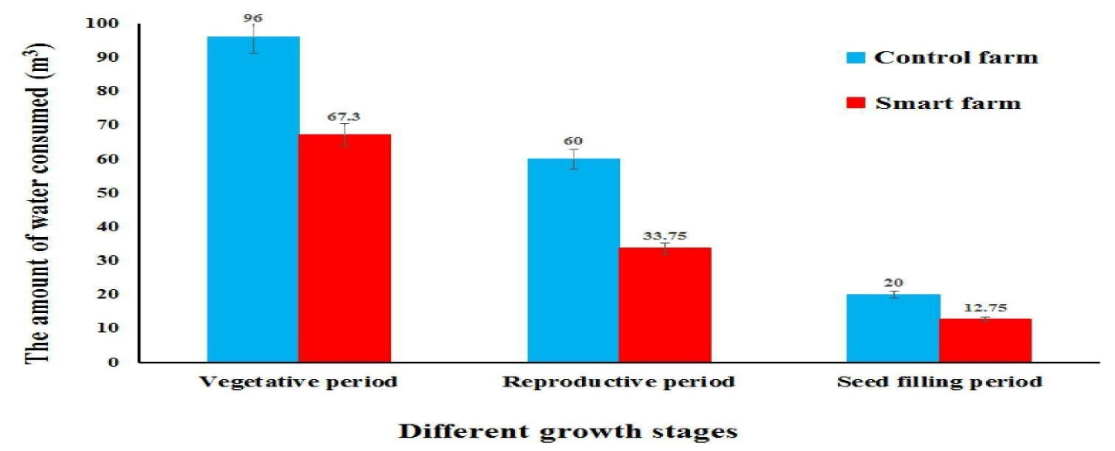
Snapshot 5.5: Different growth stages

This is the initial stage where the seed begins to sprout and develop roots. Adequate soil moisture is very important during this stage to support seed activation and early growth. Insufficient water can lead to poor germination. Seedling StagIn this stage, small leaves and roots start developing. The plant is sensitive to environmental stress, and regular but
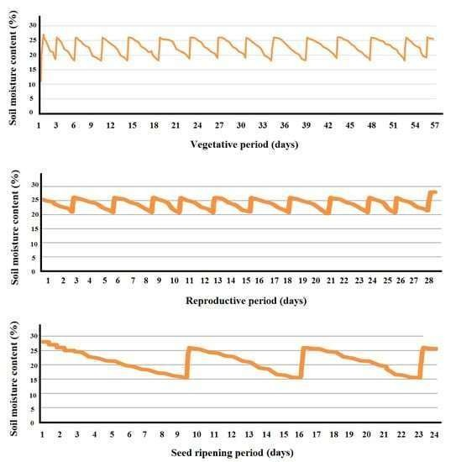
Snapshot 5.6: Moisture percentage at different times
The moisture percentage in the soil varies at different times of the day due to factors such as irrigation, temperature, evaporation, and plant water uptake. Immediately after irrigation or rainfall, the soil moisture percentage is high as water is retained in the root zone. As time progresses, especially during daytime, moisture levels gradually decrease due to evaporation caused by sunlight and absorption of water by plant roots.
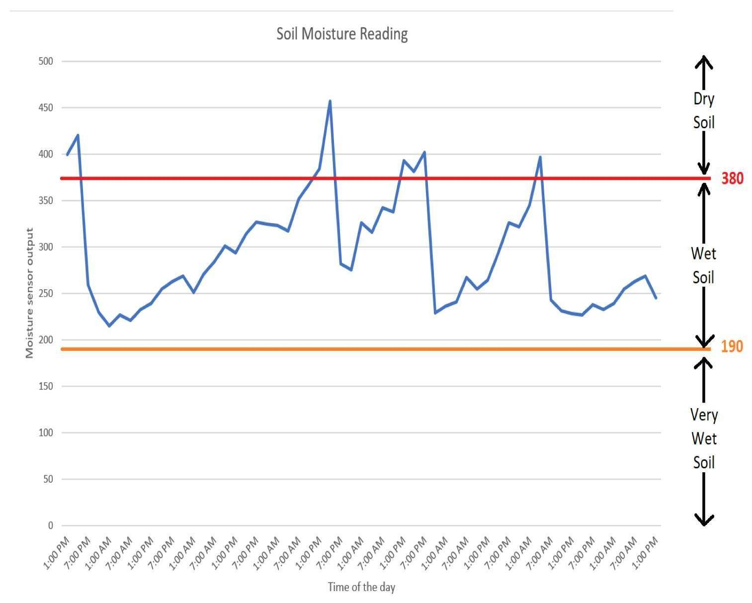

Snapshot 5.7: Soil moisture variation for one week
Over the course of one week, soil moisture levels typically fluctuate due to changes in environmental conditions such as rainfall, temperature, and humidity. During periods of rainfall or irrigation, soil moisture increases as water infiltrates the soil, replenishing the
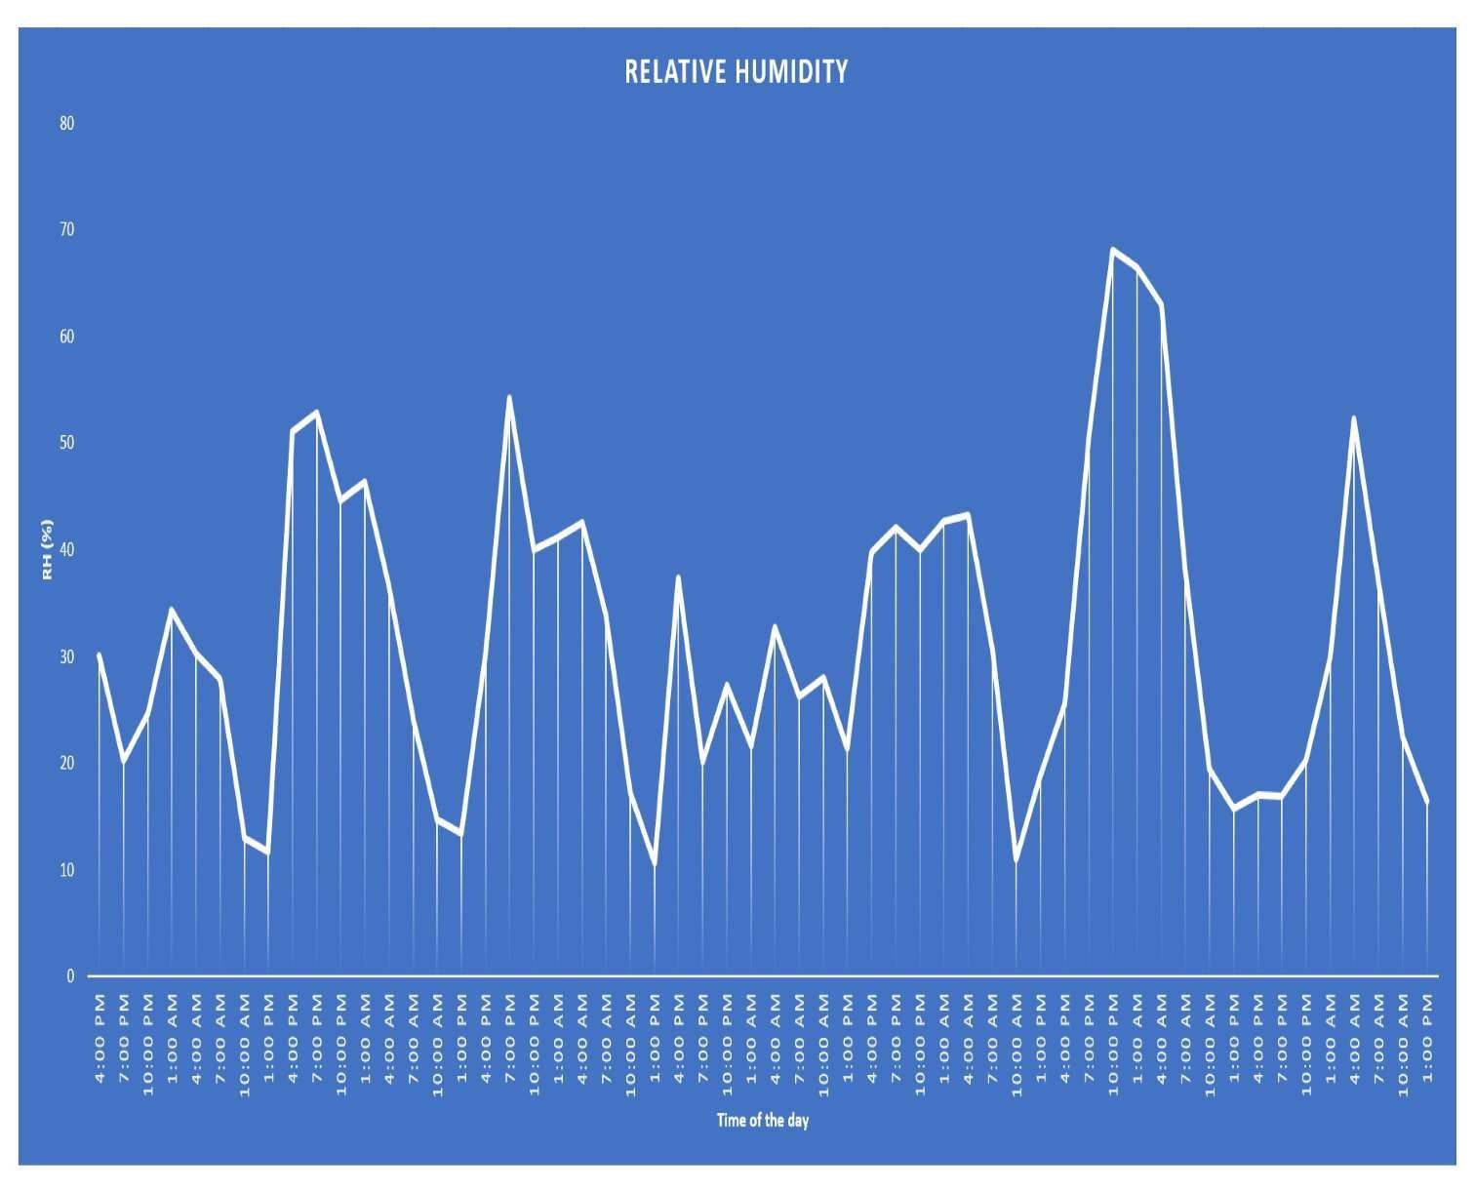

Snapshot 5.8: Humidity fluctuation throughout the week.
Humidity levels over the course of a week generally show noticeable variation due to changes in weather conditions, temperature, and environmental factors. During early mornings and late evenings, relative humidity tends to be higher because cooler temperatures reduce the air’s capacity to hold moisture. In contrast, during midday when temperatures rise, humidity usually drops as warm air can hold more water vapor, causing a lower relative humidity.
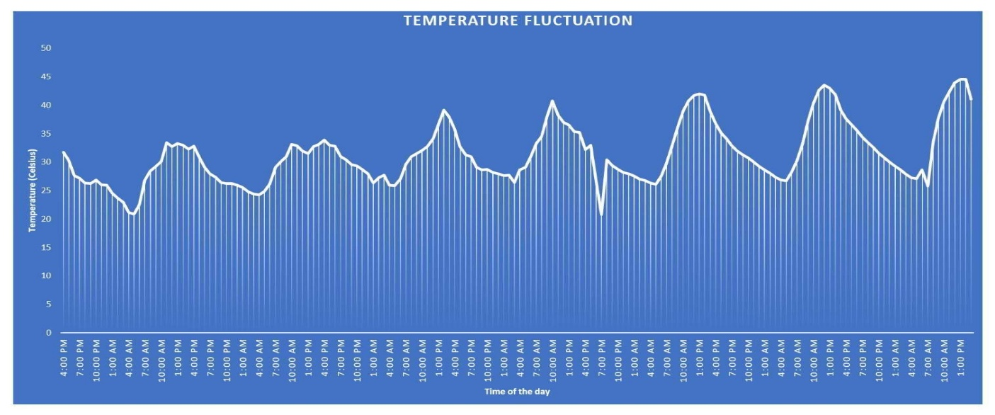
Snapshot 5.9: Temperature fluctuation throughout the week.
Temperature throughout a week typically varies due to daily and seasonal changes, weather patterns, and sunlight intensity. During daytime, temperatures usually rise, reaching a peak in the afternoon, while nights are cooler due to the absence of solar heating. Cloud cover, wind,
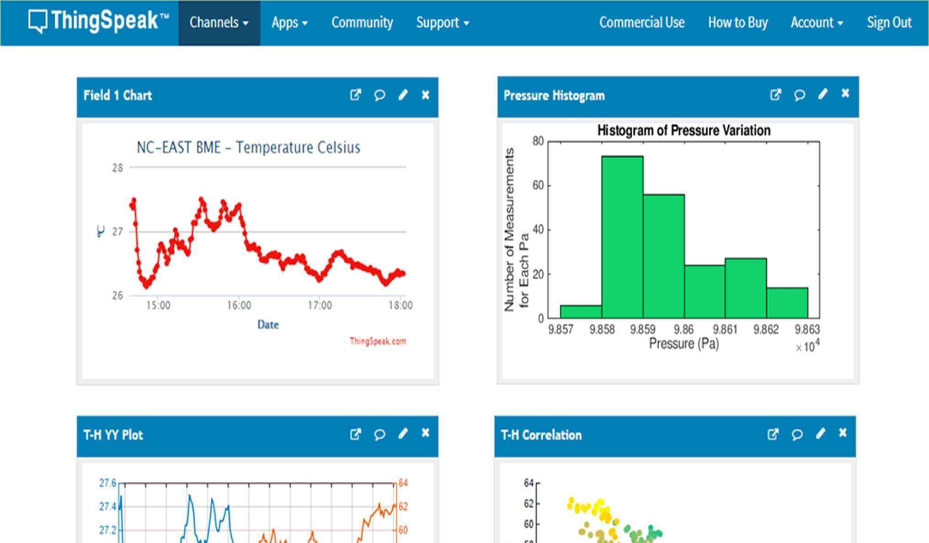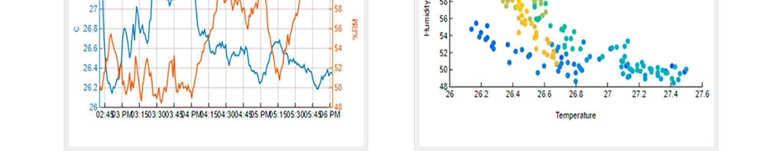

Snapshot 5.10: Cloud Dashboard (ThingSpeak)
This dashboard shows real-time sensor readings uploaded to the cloud. The user can remotely monitor soil moisture, temperature, humidity, and pump status from anywhere. By continuously monitoring soil moisture, the system ensures optimal water usage, resulting in healthier crops and improved productivity. The solution is cost-effective, scalable, and easy to implement, making it suitable for small gardens to large agricultural fields • The ON/OFF status graph shows when the relay activated the pump.
- Each ON cycle matches the drop in moisture readings.
- Each OFF cycle matches the rise in moisture after watering.
CHAPTER 6

Conclusion and Future Scope

6.1 Conclusion
The IoT Smart Irrigation System successfully automates the irrigation process by using real-time sensor data to control water supply efficiently. The project demonstrates how IoT technology can reduce water wastage, minimize manual effort, and support precision agriculture. By continuously monitoring soil moisture, the system ensures optimal water usage, resulting in healthier crops and improved productivity. The solution is cost-effective, scalable, and easy to implement, making it suitable for small gardens to large agricultural fields. Overall, the project highlights the importance of smart technologies in modern farming and provides a foundation for future innovations in sustainable agriculture.

The IoT Smart Irrigation System represents a major step toward modernizing traditional agricultural practices by integrating technology, automation, and data-driven decision-making. In an era where water scarcity, climate change, and unpredictable weather patterns pose serious challenges to farming, the need for intelligent irrigation systems has become essential. This project demonstrates how IoT-based solutions can transform agricultural operations, conserve vital resources, and maximize crop productivity with minimal human intervention.

6.2 Future Scope
The IoT Smart Irrigation System has significant potential for further development and expansion. In the future, the system can be enhanced by integrating machine learning to predict water requirements based on weather forecasts and historical soil data. Solar-powered operation can be added to make the system energy-efficient and suitable for rural areas. Mobile app notifications, voice-assistant control, and advanced dashboards can improve user interaction. The system can also be extended to support large-scale farms with multiple sensor nodes using LoRa or GSM communication. Fertilizer monitoring, crop-health analysis, and automated nutrient fully intelligent, sustainable farming solution.
The IoT Smart Irrigation System developed in this project marks an important milestone in transforming agricultural practices through automation and intelligent decision-making. Although the current system successfully automates irrigation using real-time soil moisture data, it holds a vast potential for expansion and enhancement in the coming years. With rapid advancements in IoT, artificial intelligence, wireless communication, and sustainable technologies, this system can evolve into a fully autonomous, data-driven, and energy-efficient smart farming solution. The following points describe the major future scope areas where the system can be improved and extended.

- Integration of Machine Learning and AI-Based Predictions
One of the most promising future improvements is incorporating machine learning models to predict irrigation needs. Instead of relying only on real-time soil moisture values, the system can analyze historical soil data, crop type, temperature patterns, and rainfall forecasts to automatically plan irrigation schedules. AI algorithms can identify patterns in crop water consumption, detect early signs of drought stress, and adjust watering levels accordingly. Predictive analytics can further help in optimizing water usage, reducing wastage, and improving crop health. Such intelligent irrigation systems will support sustainable farming by providing precise water delivery based on environmental data and crop requirements.

- Solar-Based Power System for Rural and Remote Farming Areas
Many agricultural fields lack stable electricity access, especially in remote villages. A highly beneficial enhancement is the integration of solar-powered operation for the IoT Smart Irrigation System. Using solar panels, rechargeable batteries, and low-power microcontrollers, the system can function continuously even in off-grid areas. Solar-based IoT irrigation makes the system environmentally friendly, . Using solar panels, rechargeable batteries, and low-power microcontrollers, the system can function continuously even in off-grid areas. Solar-based IoT irrigation makes the system environmentally friendly, cost-effective, and suitable for farmers with limited resources.
- Expansion for Large-Scale Farms Using LoRa, GSM, and ZigBee
The current system works efficiently for small to medium-sized farms using Wi-Fi-based communication. However, large-scale agricultural fields require long-range communication technologies such as LoRa (Long Range), GSM, and ZigBee. LoRa can transmit sensor data over several kilometers with minimal power consumption, making it ideal for wide farmlands. GSM modules enable farmers to control the irrigation system through SMS commands, making it suitable even in areas with no internet connectivity. Integrating these technologies will allow the system to scale from small gardens to commercial farms and agricultural estates.

- Mobile App Development and Smart User Interface
A dedicated mobile application with advanced features can significantly enhance user interaction.
Through the mobile app, farmers can:
- Monitor soil moisture, weather conditions, and pump status
- Receive instant alerts and notifications
- View historical trends and analytics
- Control the pump manually
- Customize thresholds and irrigation schedules

- Multi-Sensor Integration for Complete Smart Farming
The future version of this system can incorporate additional sensors to create a more holistic smart farming solution. These may include:
  - Temperature and humidity sensors
  - Rainfall sensors
  - Soil pH and nutrient sensors
  - Light intensity (LDR) sensors
  - Crop disease detection sensors
By combining these sensors, the system can analyze various environmental factors and guide farmers on irrigation, crop health, fertilizer requirements, and pest control. This transforms the system into an advanced precision agriculture platform.
- Cloud-Based Data Analytics and Farm Dashboard
A comprehensive cloud dashboard can be developed to visualize long-term trends, compare crop performances, and generate detailed reports. Cloud analytics can help farmers and agricultural This data-driven approach supports better planning, improved decision-making, and optimized researchers understand:
- Seasonal water usage
- Crop growth patterns
- Irrigation efficiency
- Soil moisture fluctuations
- Weather-influenced changes

